|  |  |  |  |  |  |
| --- | --- | --- | --- | --- | --- |
| **Picnic Area Accessibility Tool**  **(Will need to complete one per shelter at each park)** | | | | | |
| PA1. | Name of Park: | | | | |
| PA1a. | Number of picnic areas assessed: | | | | |
| PA1b. | Name/location of picnic area: | | | | |
| **Yes No N/A Photo?** | | | | | |
| PA2. | Is there an accessible route of travel from parking area to picnic area? (access means firm surfaces, clear of obstacles) |  |  |  |  |
| PA2a. | Distance from parking to picnic area: ____ feet |  |  |  |  |
| PA2b. | Describe the surface of the route of travel: |  |  |  |  |
| PA3. | Are accessible picnic tables available? |  |  |  |  |
| PA3a. | If so, how many picnic tables are accessible? ____ tables |  |  |  |  |
| PA3b. | If so, are tables evenly dispersed among various picnic areas at this site? (i.e. is there at least one accessible picnic table available where other picnic tables are situated) |  |  |  |  |
| PA4. | Indicate the various placements of picnic tables:  ____sun ____shade ____pavilion or picnic shelter |  |  |  |  |
| PA5. | Are the surfaces of the areas below and surrounding the picnic tables firm and stable? |  |  |  |  |
| PA6. | Comments/additional information regarding the picnic areas: | | | | |
| **Grills, cooking surfaces, or pedestal grills Yes No N/A Photo?** | | | | | |
| GR1. | Is the grill located on and surrounded by a firm and stable surface? |  |  |  |  |
| GR2. | Is there 48 inches of clear ground space available to access the cooking/grill area? |  |  |  |  |
| GR3. | How high are the cooking surfaces above the ground or floor surface?  ____ inches (min of 15” and maximum of 34”) |  |  |  |  |
| GR4. | How high above the ground are the cooking controls? ____ inches  (between 15” and 48” high) |  |  |  |  |
| GR5. | Comments/additional information regarding grill area: | | | | |
| **Fire Rings Yes No N/A Photo?** | | | | | |
| FR1. | Is the fire ring surrounded by a firm and stable surface? |  |  |  |  |
| FR2. | Is there 48 inches of clear ground space available to access the fire ring? |  |  |  |  |
| FR3. | How high is the fire building surface from the ground or floor? ____ inches  (minimum of 9”) |  |  |  |  |
| FR4. | Where a raised edge or curb is provided on a fire ring, how high is the top of the edge or curb down to the cooking surface? ____ inches  (24” maximum) |  |  |  |  |
| FR5. | Comments/additional information regarding grill area: | | | | |

Name of person who completed assessment: ___________________________ Date: _________

**Picnic Area Accessibility Tool Information**

Examples of accessible picnic tables:

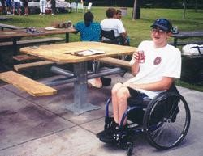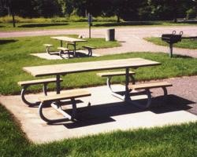

Fixed pedestal square table with one bench removed. This table allows for more than one person using a

wheelchair to sit at the same table,

and gives choice of seating spaces to a person using a wheelchair.

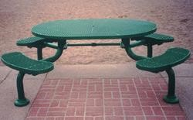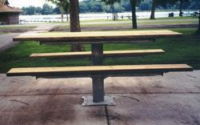

Center Post offers space on either end An oval tabletop allows the center of the table to be within reach range while seated at any position.

Information and photos gathered from [**http://www.ncaonline.org/monographs/4picnictables.shtml**](http://www.ncaonline.org/monographs/4picnictables.shtml)