Fishing Pier / Platform Accessibility Tool
FP1. | Name of Park:
FP1a. | Number of fishing piers/platforms assessed:
FP1b. | Name/location of fishing pier
Yes No N/A Photo?
FP2. | Is there an accessible route of travel from the parking area to the fishing pier? (access means firm surfaces, clear of obstacles)
FP2a. | Describe the surface of the route of travel:
FP3. | Is there a gangway or slope to the fishing pier?
FP3a. | If there is a gangway or slope, provide measurement of slope: ____%
FP4. | How wide is the fishing pier? _____ inches
FP5. | Is there a railing along the fishing pier?
FP5a. | If yes, how high is the railing? _____ inches (at least 25% should be 34” or less)
FP5b. | If there are sections of the railing that are lower than others, how high are the lowest sections? _____ inches
FP5c. | Is there toe clearance under the railing? (minimum of 9 inches high and 30 inches wide)
FP5d. | If yes, provide toe clearance measurements: ____ inches high x ____inches wide
FP6. | If there is no railing, is there edge protection? (min 2 inches high)
FP7. | Is there at least one clear space near the edge protection or railing on the pier? (30”x48” space for a person in a wheelchair or chair to sit )
FP8. | Is there at least one maneuvering space on the pier? (60” circle)
FP9. | Comments/additional information regarding fishing pier:

Name of person who completed assessment: ___________________________ Date: ____________

Fishing Pier Accessibility Tool Information

Fishing Piers and Platforms (ADAAG 15.3)
Under the Americans with Disabilities Act (ADA), the Access Board has developed guidelines for recreation facilities that were previously made available for public comment. Presented here are highlights of the final version, which includes changes made as a result of the Board’s review of public comments.
This section addresses railings and edge protection on fishing piers and platforms. Railings, guardrails, and handrails are not required by the guidelines. However, where they are provided, a portion (at least 25%) cannot be more than 34 inches high so that the railings do not obstruct fishing for people using wheelchairs. An exception permits the use of a guard complying with the International Building Code where required by other authorities. Lowered railings are required to be dispersed throughout a fishing facility.
FP6: Edge protection at least 2 inches high is used to prevent the wheels of mobility aids from slipping over the edge.

15.3.3.1 Edge Protection 15.3.3.3 Dispersion 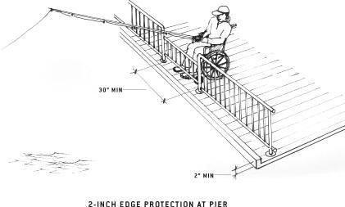
This provision requires edge protection that extends 2 inches minimum above the ground or deck surface. An exception provides that where the railing, guardrail, or handrail is 34 inches or less above the ground or deck surface, edge protection is not required if the deck surface extends 12 inches minimum beyond the inside face of the railing. The toe clearance must be 9 inches minimum above the ground or deck surface beyond the railing and be 30 inches minimum wide.
This section requires that lowered railings be dispersed throughout a fishing pier or platform.

15.3.4 Clear Floor or Ground Space
This section requires that at least one clear floor or ground space complying with ADAAG 4.2.4 be provided where the lowered railing height is located. Where no railings are provided, at least one clear floor or ground space complying with ADAAG 4.2.4 must be provided. No substantive comments were received and no changes were made to this provision for the final rule.

15.3.5 Maneuvering Space
This section requires that at least one maneuvering space complying with ADAAG 4.2.3 be provided on a fishing pier or platform. The maneuvering space is permitted to overlap the accessible route and the clear floor space required by 15.3.4. No substantive comments were received and no changes were made to this provision for the final rule.

